**Rest API CURD Operation Evidence with Security**

**ii) Provide Screenshots of the operations(PostMan/Browser) along with code submission. (note → Screenshots will one of the criterias while grading)**

1. http://localhost:8083/api/employees/employeesList

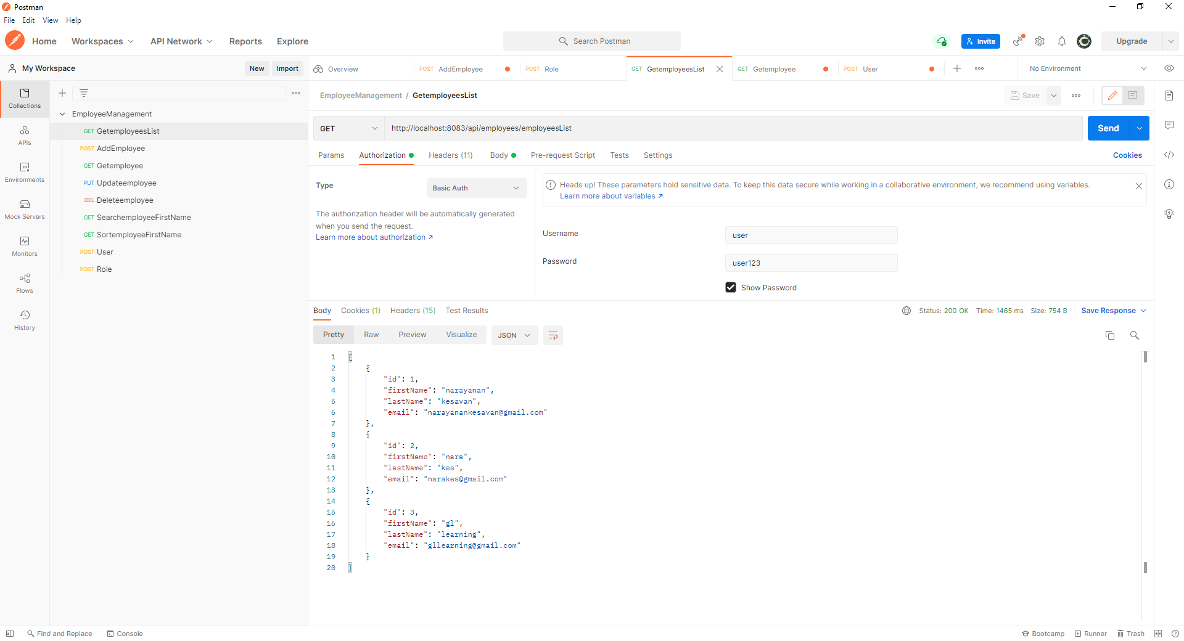

1. <http://localhost:8083/api/employees/add>

Sample Request:-

{

    "firstName":"gl",

    "lastName":"postman",

    "email":"postman@gamil.com"

}

Sample Response:-

Employee Added Successfully!

Added Employee Details is :

id : 4

First Name : gl

Last Name : postman

Email : [postman@gamil.com](mailto:postman@gamil.com)

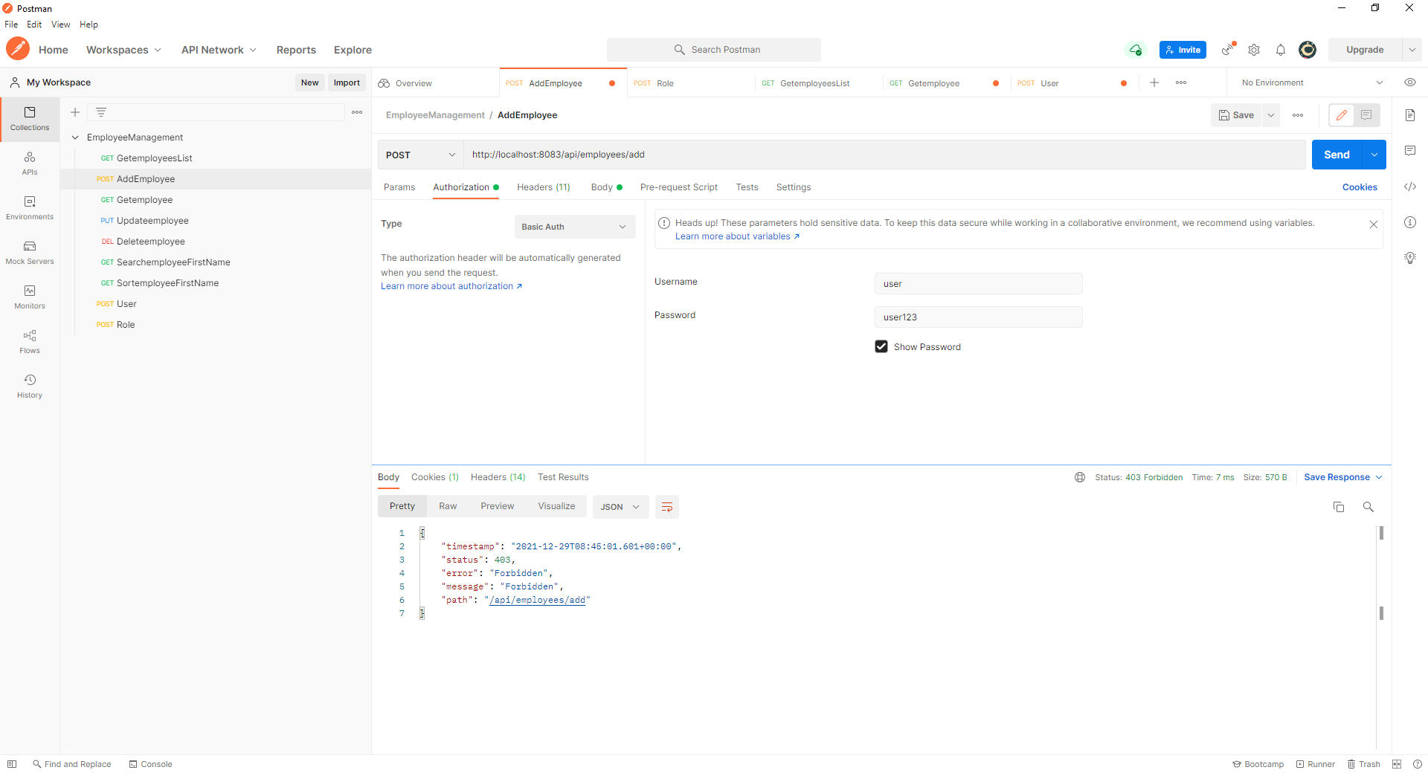

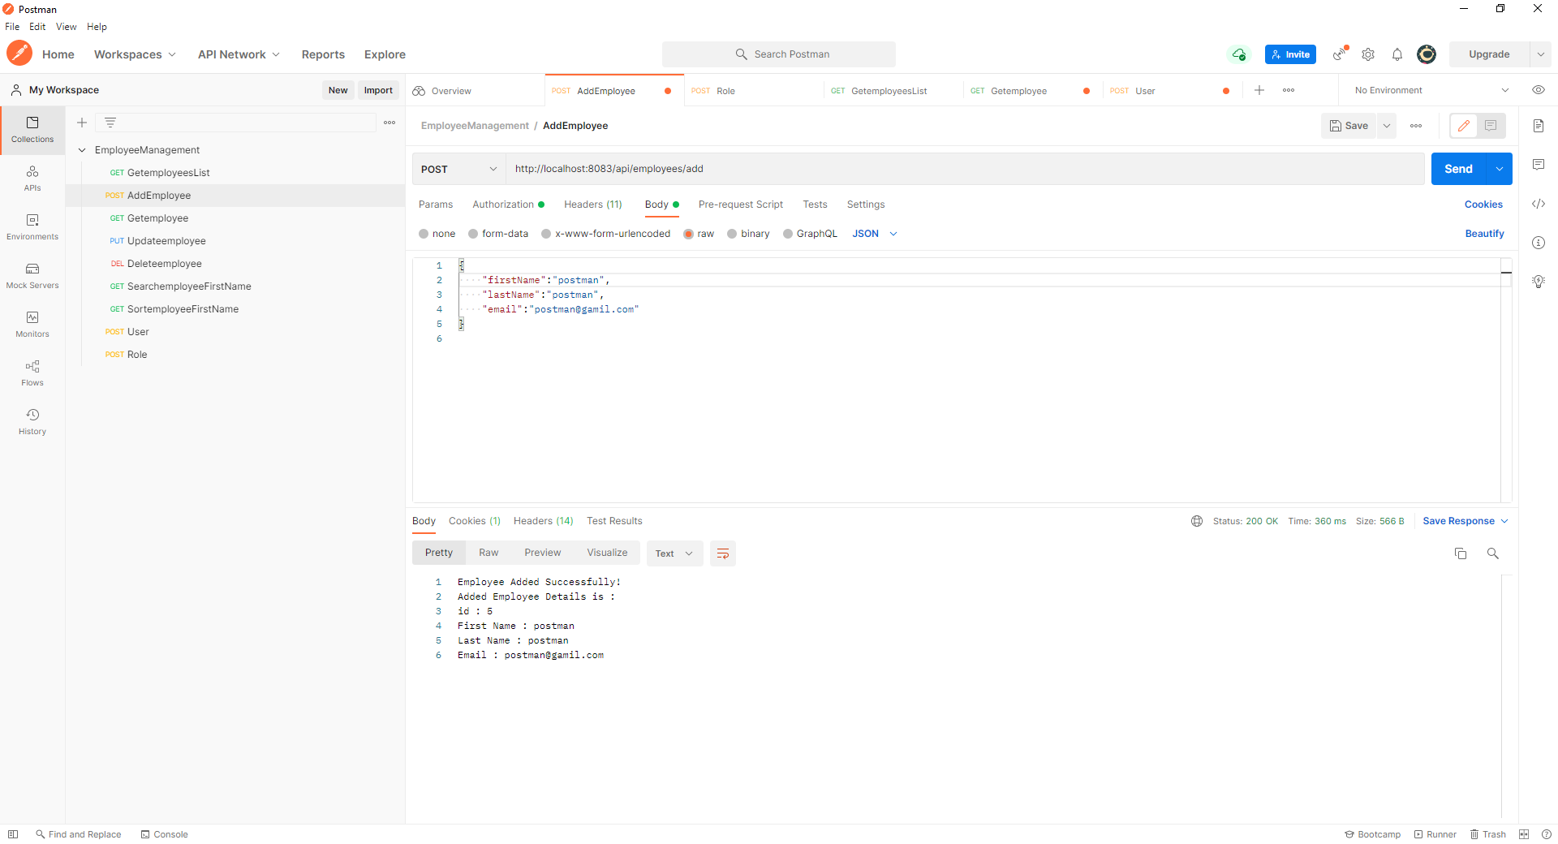

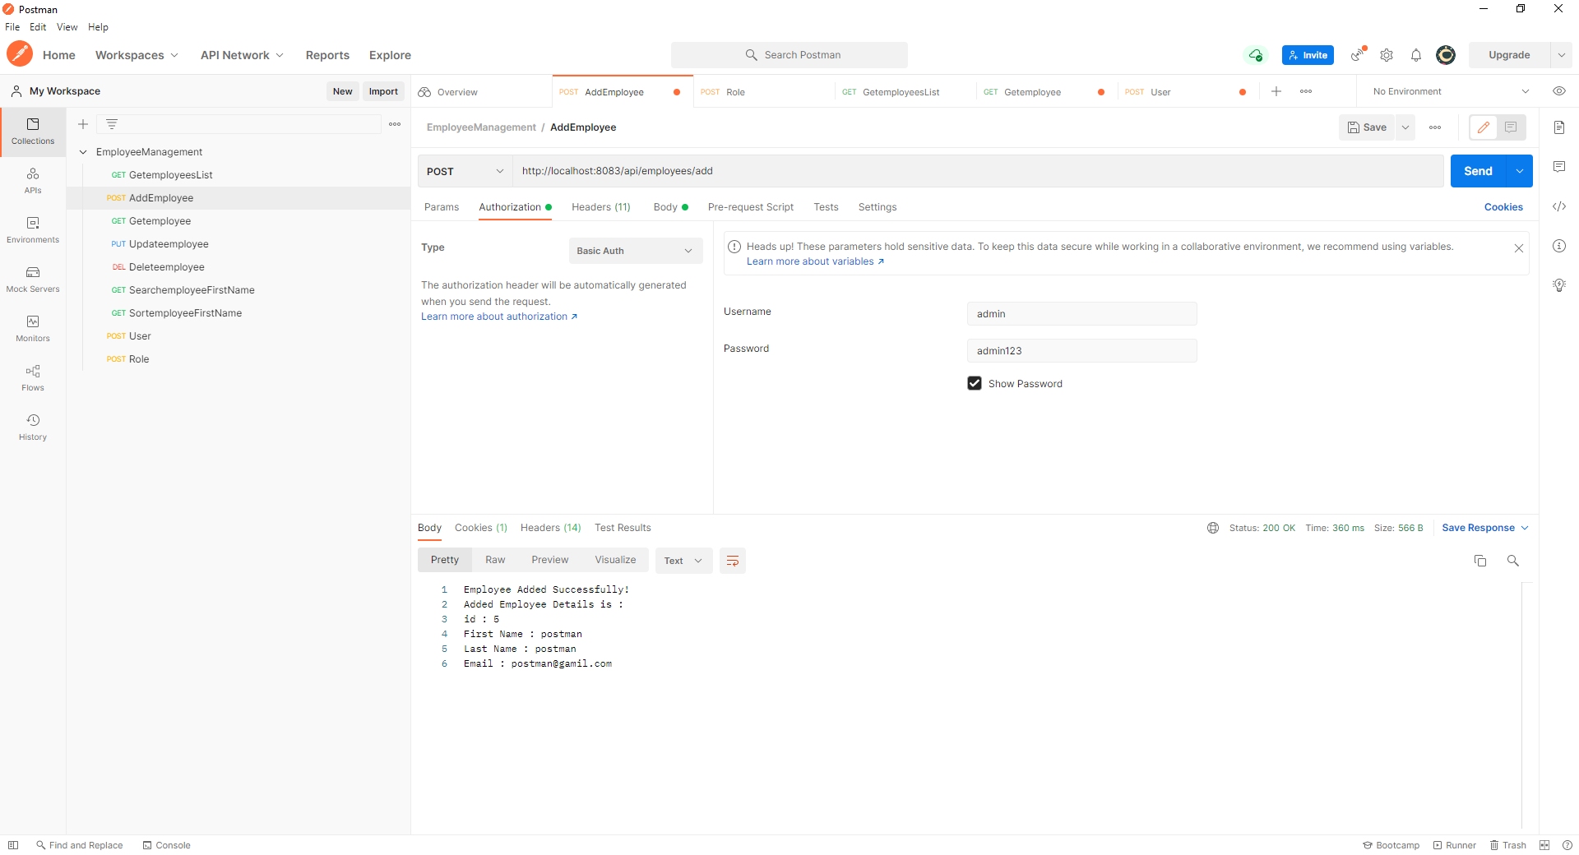

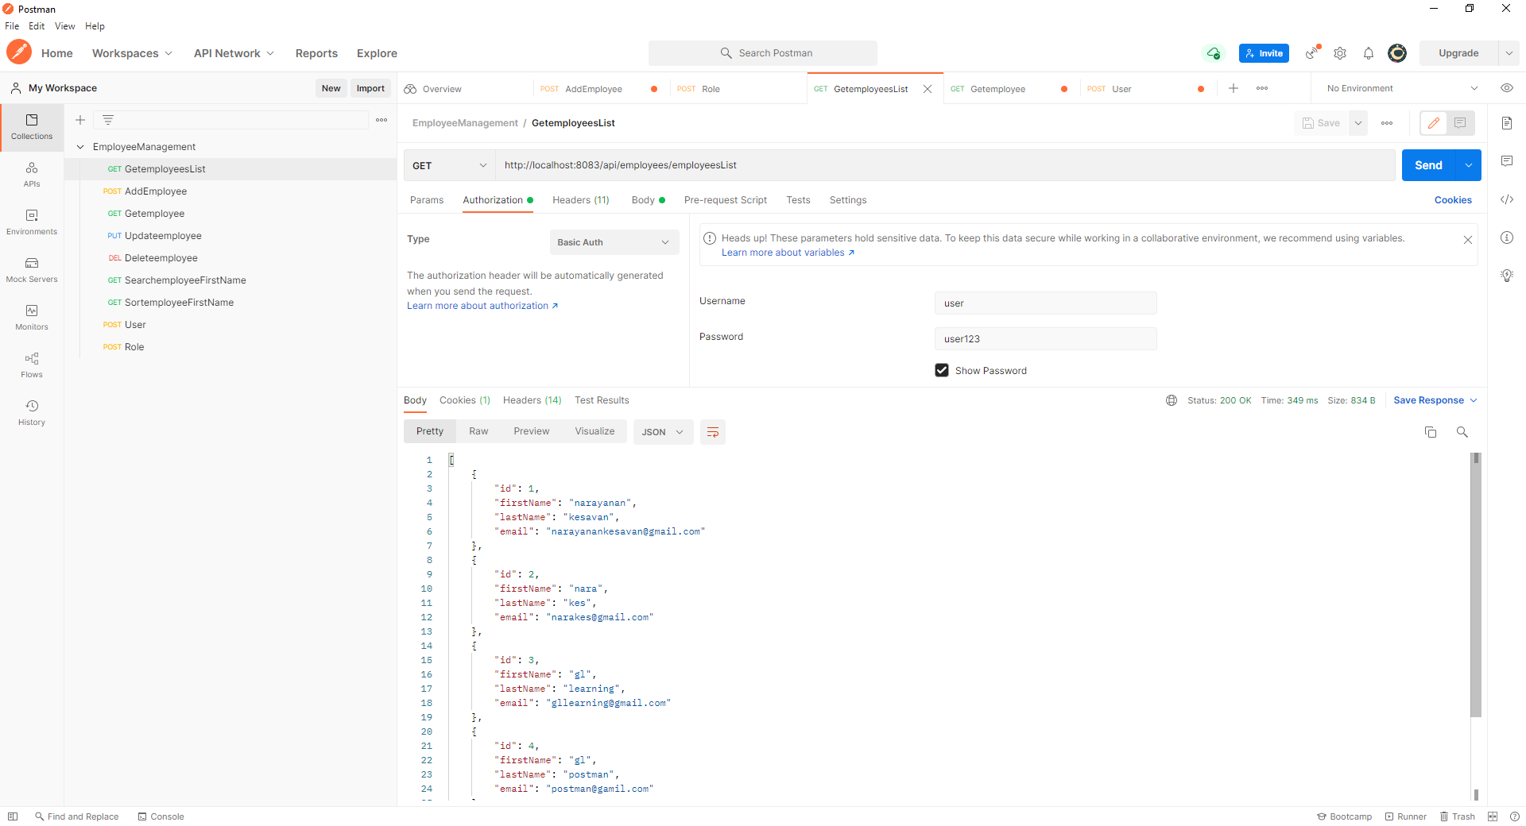

3. http://localhost:8083/api/employees/2

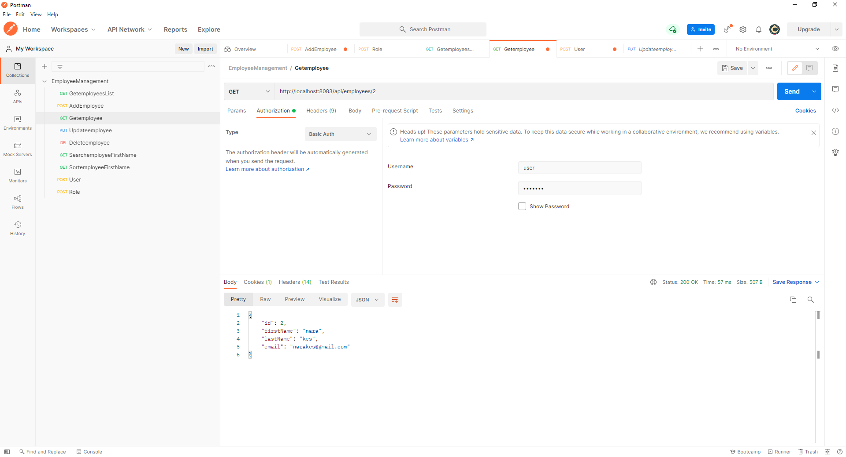

1. <http://localhost:8083/api/employees/update>

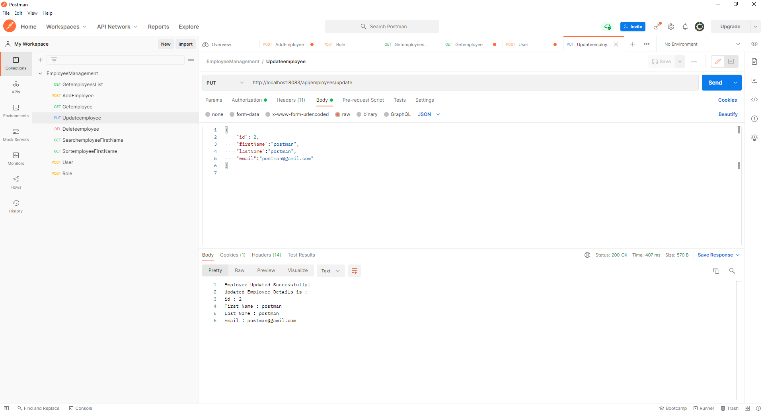

1. http://localhost:8083/api/employees/delete/2

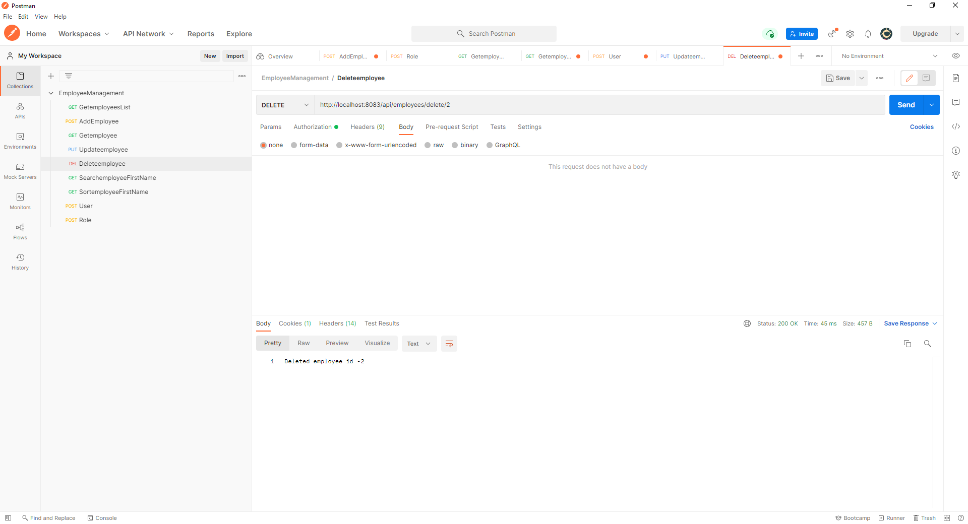

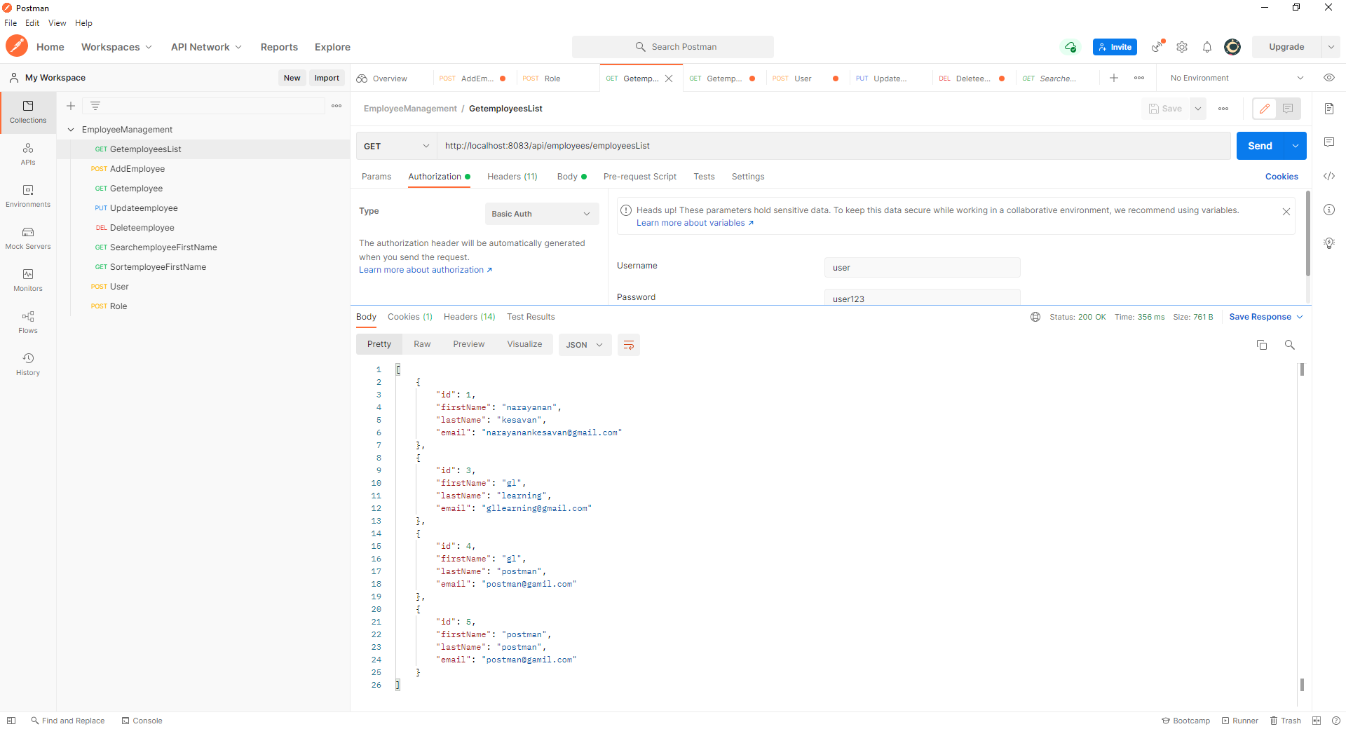

1. <http://localhost:8083/api/employees/search/gl>

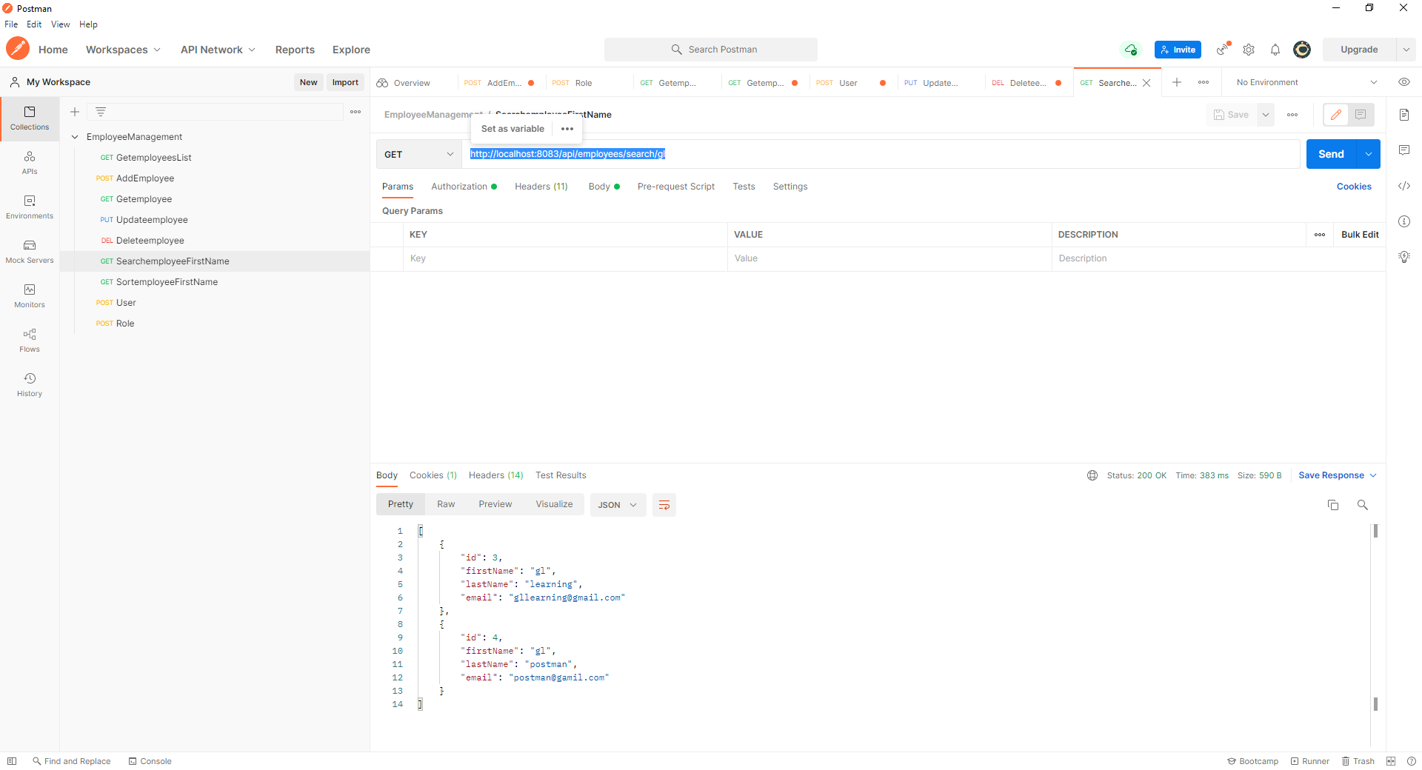

1. <http://localhost:8083/api/employees/sort?order=desc> or <http://localhost:8083/api/employees/sort?order=asc>

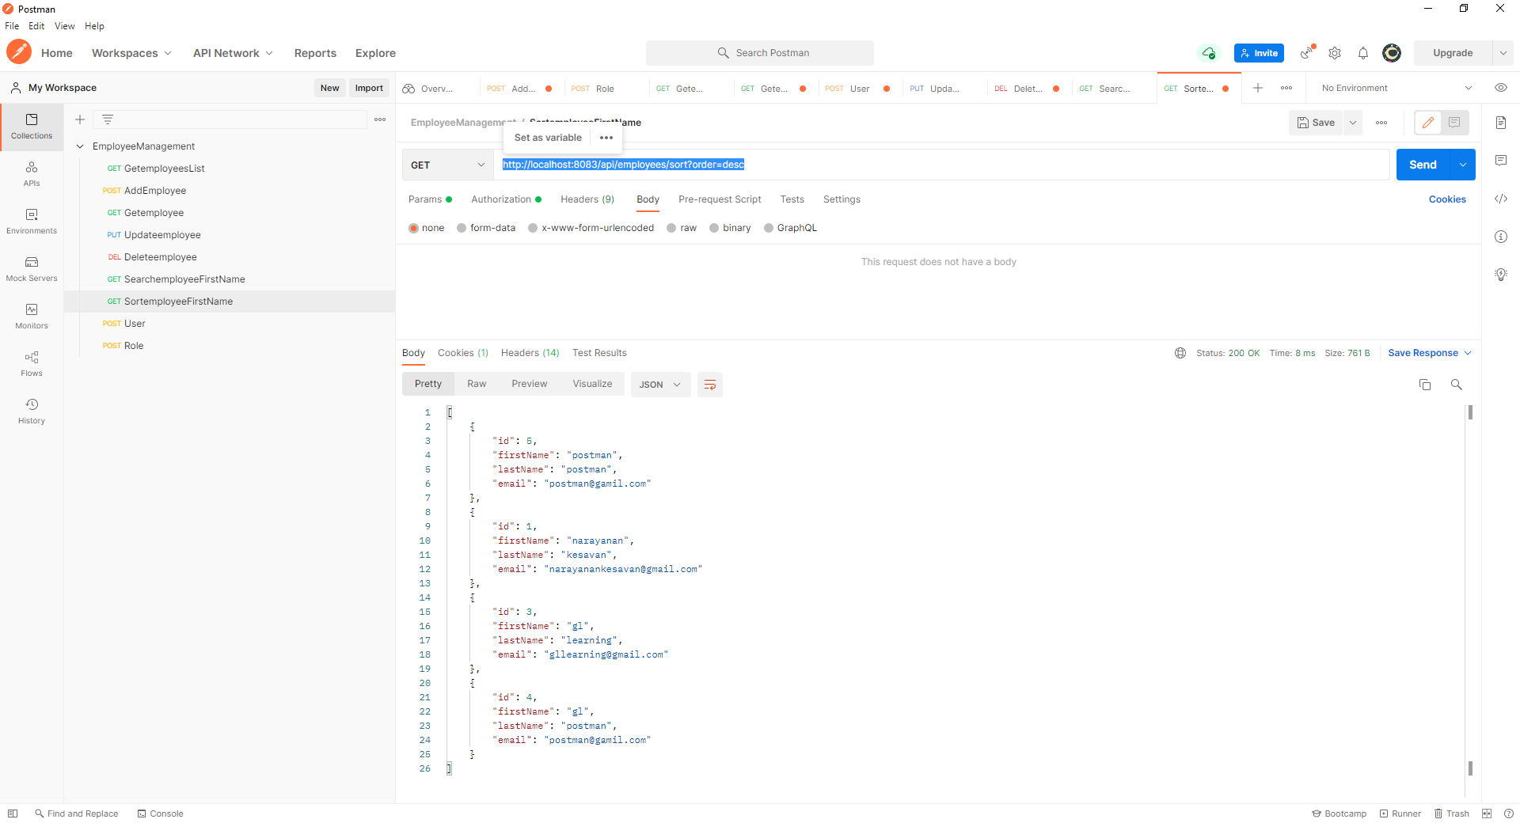

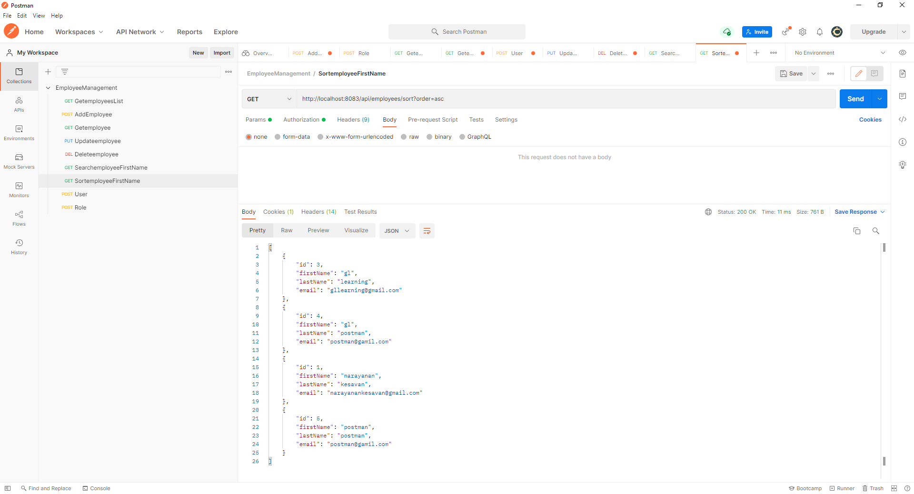

1. <http://localhost:8083/api/user>

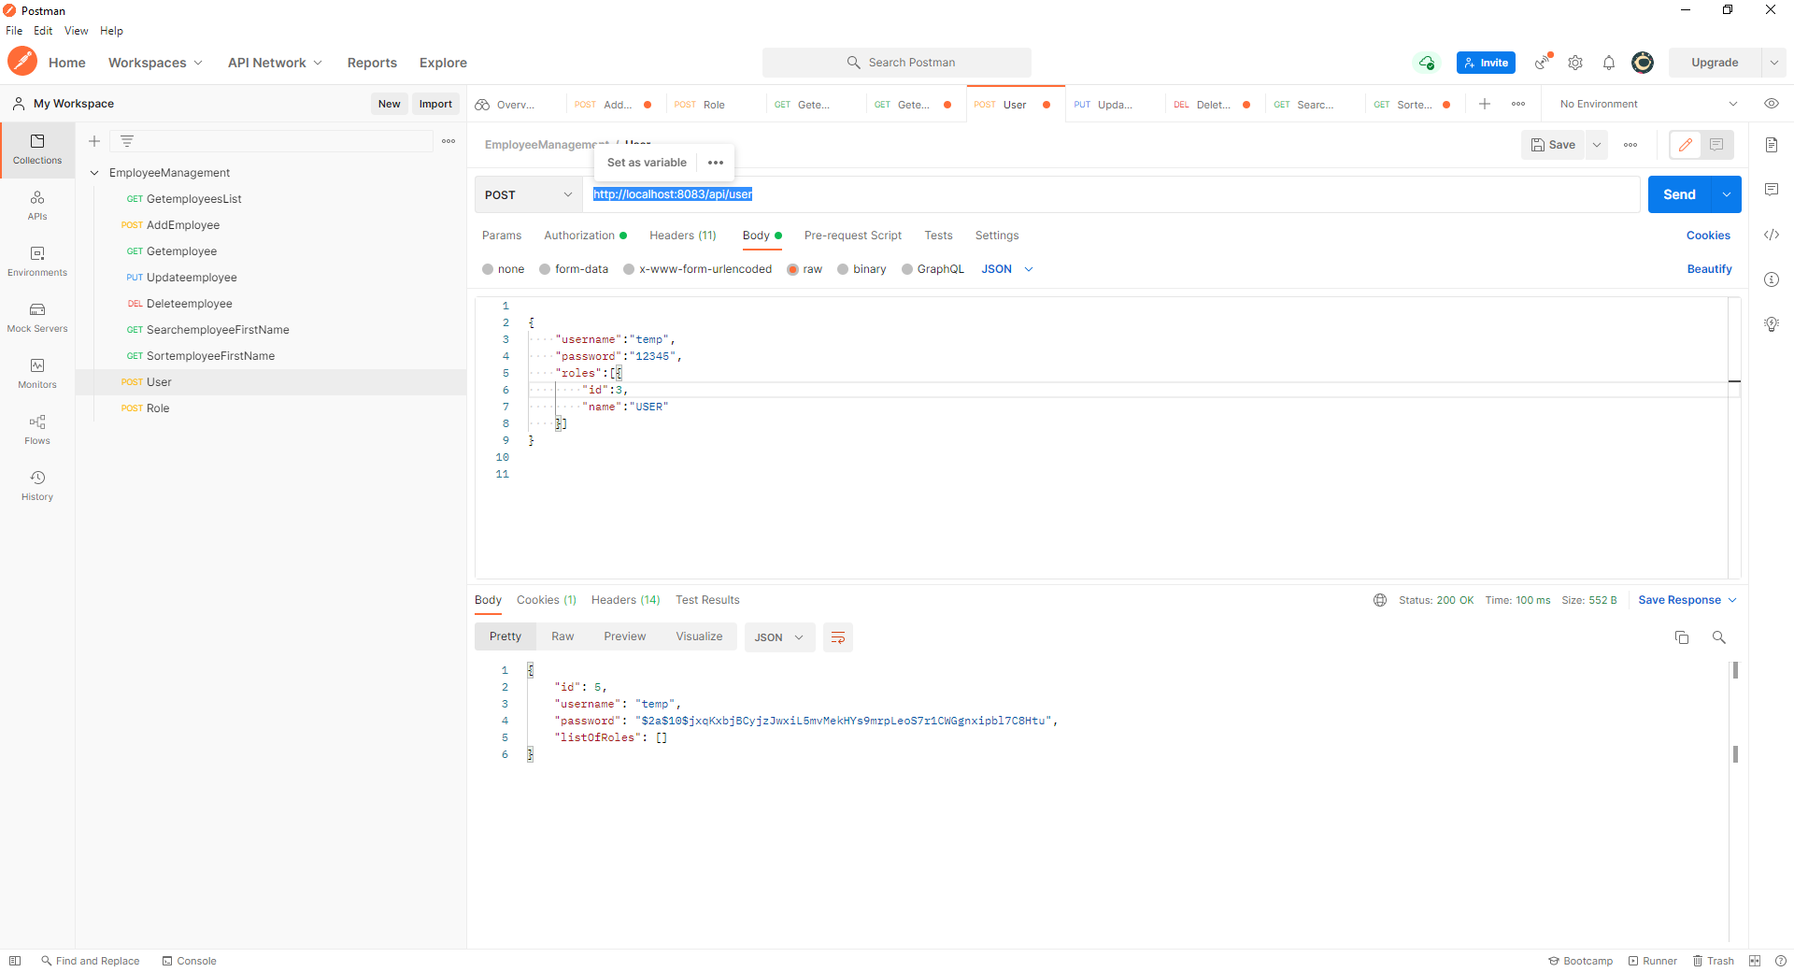

1. <http://localhost:8083/api/role>

